ANIMALS ON BIKES EYE SPY FAMILY QUIZ 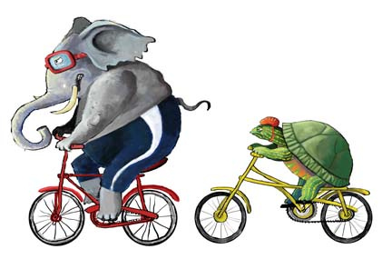
Start your tripometer on 000 as you turn off the Mitchell Highway from Molong onto Obley rd/Banjo Patterson Way. The following “paddock art” sculptures are in order from Molong-Cumnock- Yeoval-Dubbo;
- Packwell (First in Australian Animal category) by John Packham & Stuart Caldwell
Description; Oversize copy of veteran motorcycle with 2 blue heeler dogs on board rounding up the cattle
Distance; 4.38km from Molong Mitchell highway (right hand side amongst trees)
Eye Spy; What animals can you see on and around this large sculpture?

- Spikes on Spokes by the Marriott Family
Description; Spike family of echidnas en route to Banjo Paterson Way Ant Eating Festival
Materials; Saw blades, parts of T Robinson & Co Pty Ltd harvester (circa 1920) & random scrap metal
Distance: 8.12km from Molong (left hand side)
Eye Spy; How many echidnas on the bike?
Draw a kangaroo riding a bicycle here

- Jump on Wheels by the Molong Men’s Shed
Description; Kangaroo on a large pennyfarthing
Distance; 11.8km from Molong (left hand side)
Eye Spy; What is another name for a kangaroo?

- Lizzy (2nd in Australian Animals and People’s Choice Award)
by Graeme Fleming & Mal Williams
Description; Lizzy the frillneck lizard with handbag and
hat on a penny farthing bike
Materials; scrap material from a farm rubbish tip at Bourke NSW
Distance; 13.9km (right hand side)
Eye Spy; What colour is Lizzy’s nailpolish?

- Bit between the Teeth by Ivan Pine
Description; Horse with arm in the air riding a Go-cart
Distance; 15km (right side)
Eye Spy; Which direction is this sculpture facing?

- Catch Me If You Can by Andy Kerr
Description; Wind positional corrugated iron and iron post kangaroo
on a bush fire red postman’s bike
Distance: 18.7km (left side)
Eye Spy; How does this sculpture spin around?

- Rambo by Phillip King
Description; Mulsed Ram with horns and 2 blow-flys buzzing around behind
Materials; fencing wire, old cart wheels, auger head and parts from Cumnock backyard tip
Placement; 19.6km from Molong after “Tallowood” on Rosehill Lane corner (right side)
Eye Spy; How many blowflys are buzzing around this sheep?

- Fizzy the Elephant by Christine Weston
Description; Bright pink baby elephant with sparkly crown reaching for little pink diamante bike
Distance: 20.3km and after “Golden Glen” gates (left side under trees)
Eye Spy; What is on the elephants back?

- Cow Jumped Over the Moon by the Cumnock Playgroup
Description; Cow riding a bike and jumping over the moon
Distance: 21km from Molong (left)
Eye Spy; How is the cow going to reach the moon?

- Ezyrider (2nd in Farmer category)by Don Bruce
Description; Giraffe riding a trike -corrugated iron cut individually, 1960s plough frame and wagon wheel parts
Placement; 21.5km from Molong and only 0.8km to Cumnock (right side)
Eye Spy; Which town is this giraffe looking at?

- “K-T-Bird” Horse and Jockey by David Weston
Description; red, white and blue horse riding a scooter with jockey sitting behind encouraging him to go faster
Materials; 44 gallon drum, 20 litre chemical drums, 4wd shock absorbers, float valve, grader blade, horse drawn cycle mower, farm metal scraps
Placement; opposite Cumnock Royal Hotel (right)
Eye Spy; What colour is the jockeys hat?

Turn left at the Cumnock Royal Hotel down McLaughlan St just 500m and stop at Cumnock Police Station (left side)

- Hog on a Chopper by Mick Bates (First in Letterbox category)
Draw your favourite farm animal
Description; Pig riding a flash motorbike
Eye Spy; What is this pig wearing?

- Next door at 19 McLaughlan St is the other 2 Little pigs
riding a motorbike by Matty Bone
Description: 2 pigs, an owl and lizard on a motorbike
Eye Spy: What animal is sitting on the petrol tank?

Make a U-turn and drive back to Obley St, turn left at the pub

- Sea Eagle lost in a paddock by Lou Spicer
Sea Eagle landing on large motorbike doing a mono –made from sheet metal, old wheels, bikes
Placement; opposite CWA building in centre of Cumnock town 150m from Cumnock Royal hotel (right)
Eye Spy; What rugby league team does he play for?

- Spotty the Caterpillar (2nd in Group category) by Cumnock Village Preschool
Description; 4m long caterpillar sitting on fence riding 3 bikes with lots of gumboots. 500m from hotel before bridge on left
Eye Spy; How many RED gumboots is the caterpillar wearing?

- "Zip along Zebra, the water's getting cold!" (First in Foreign Animal category) by the Hiller family
Description; Hippo on sulky pulled by a unicycle riding zebra – made from everything from the tip!
Placement; next door to Cumnock Thrifty link and General store near petrol bowser (right hand side)
Eye Spy; What is the hippo sitting in?

- Flying Magpie by Gavin Smith
Description; Black and white tin Magpie riding black 20 bike on right side on the roof of takeaway cafe
Eye Spy; What is name of this takeaway café?

Start tripometer again on 000 from the Cumnock Cookies Cafe

- Hogan’s Hero by Mick Bates
Description; Emu on a unicycle camouflaged in the trees on left hand side (180m) at the gates of Hogan Transport
Eye Spy; What is the name of the Transport company this is located in?

- Chicken Trike by Callie Saul
Description; white chickens perched on a red tricycle at 55 Obley St (right hand side) 250m from Cafe
Eye Spy; How many chickens can you see?

- Go Dog Go by Andy Kerr
Description; Dog riding mail box bike with Australian flag flying at 66 Obley St Cumnock (left hand side) 250m
Eye Spy; What colour is the dog?

- Uncontrollable Ram (Highly Commended Award)by Peter Medcalf – this is a temporary structure -not weather proof
Description; Sheep on a trike which is a remote controlled wheelchair at 65 Obley St (left) 350m
Eye Spy; What is the street off Obley rd this is near?

- Ladybird by Chloe MacCarthy
Description; Bright Fluro Lady bird on a unicycle at 85 Obley St (right and 580m from café)
Eye Spy; What colour is the ladybird’s head?

- Emu on a Penny farthing by Les Roberts
Description; Very fast pedaling bush chook
Placement; 850m and left side, after bridge and about 50m up the lane near Catholic church so tricky to see
Eye Spy; What is the name of the nearby creek?
Draw a frog jumping over a bike
- Rainbow Serpent by Matt Mercer
Description; 4m long and high snake made out of old wooden
verandah brackets sitting on wheel shell
Placement; 2.25m from café and left hand side after s-bend in road
Eye Spy: What is supporting this snake so does not fall over?

- Excited Frog on a Bike by Rob and Alex Murray
Description; A very happy green frog having fun on a penny farthing
Distance; 4.6km from Cumnock café (left hand side)
Eye Spy; What colour are the frogs spots?

- Orangutan on a Skate board by Roy Butler
Description; Orangutan eating while riding on blue skateboard made out of wood board
Placement; in paddock about 100m up in hills just after bridge (right hand side and 5.4km from café)
Eye Spy; What is the orangutan eating?

- Tandem Snakes by Troy Vickers
Description; Blue tandem bike with two yellow cartoon snakes (male and female)
Placement; after gates of “Homewood” and 6.5km from Cumnock (left hand side)
Eye Spy; How many teeth can you see?

- Elephants on Bikes by Darryl Hodges
Description; Mother elephant and baby following behind (left) 7.3km
Eye Spy; What letter can you see on the elephants?

- Sheep thrills featuring Evil Ken Weevil! by James and Emily Hart
Description; Large bike made from scrap machinery parts with weevil attached to bike spoke and sheep on top.
Placement; 8.3km left side after “Yarrangrove” entrance
Eye Spy; What is the main difference between each side of the sheep?

- Yullundry Roo (First in Farmer category) by Robert Armstrong
Description; Kangaroo on a Bike (left side) and just next to Yullundry woolshed. 10.3km.
Eye Spy; What is the approx height of this sculpture?

- Scrappy Pig Junior by Robert Anderson
Description; Pig on trike made from recycled and new steel, placed on dam bank (right) 17.3km
Eye Spy; What different colour is this pig sculpture?

- Fast Animals on Bikes (First in Group category) by Wellington Men’s Shed
Description; 5 sculptures of Australian and zoo animals made from corrugated iron, scrap metal and old bikes
Placement; (left) 20.7km from Cumnock
Eye Spy; What are the 5 animals in this group?

- Duckcycle by James Blatch
Description; Duck on bike made from a Bag loader and Sunshine Harvester parts
Placement; (right side) 21 km and brown so tricky to see
Eye Spy; How far is this sculpture from the road?

- “Rough riding” by Matthew Phillipson
Description; Man stuck in back of cow after falling off bicycle
Distance: 23km from Cumnock and only 1km out of Yeoval (right side)
Eye Spy; Why did the man fall off his bike?

- “Emu on a unicycle” by Jason Guise
Description; Emu riding on a unicycle across the road from Rough riding (left side) 23 km on rocky hill
Eye Spy; What is the emu wearing on his feet?

- “Mother and Son” by Jeff Tanner
Description; kangaroo and joey on penny farthing behind the Emu on a unicycle (left side) 23km
Eye Spy; What flag is flying behind this bike?

Yeoval –turn right for coffee or snack stop – Billabong Café, and Gift and Hardware store. Stop tripometer and start again from Yeoval Royal Hotel when you continue your journey along Obley rd

- Ram on the Rocks by Karen Neale
Draw your favourite zoo animal
Description; Ram on a bike on rocks just after Yeoval (right side) 800m
Eye Spy: How many horns does this ram have?

- Rex rider (2nd in Australian Animal category) by Neville Smith
Description; Dinosaur skeleton with sharp teeth riding penny farthing,
made from Tyre, metal, header wheel
Placement; (left) 1km after Yeoval and 64.6 from Newell highway at Dubbo
Eye Spy; What colour is the dinosaur’s tongue?

- Flash Ralph by Bob Hansford
Description Emu on a bike made from chain, cog, recycled machinery parts
Placement; 11km from Yeoval and near Obley turn off (left hand side)
Eye Spy; Is this sculpture painted?

- Pigs Might Fly by Lyn Press
Description; Pink pig with wings on treadmill bike
Placement; 11km from Yeoval on right hand side near Obley turn off
Eye spy; What sort of bike is the pig riding?

- Spider on Bike by Murray Ward
Description Black spider on bike
Placement; “Hampton” letterbox (right hand side) 15km
Eye Spy: How many legs does a spider have?

- Bug on a Bike by Anna McIntyre
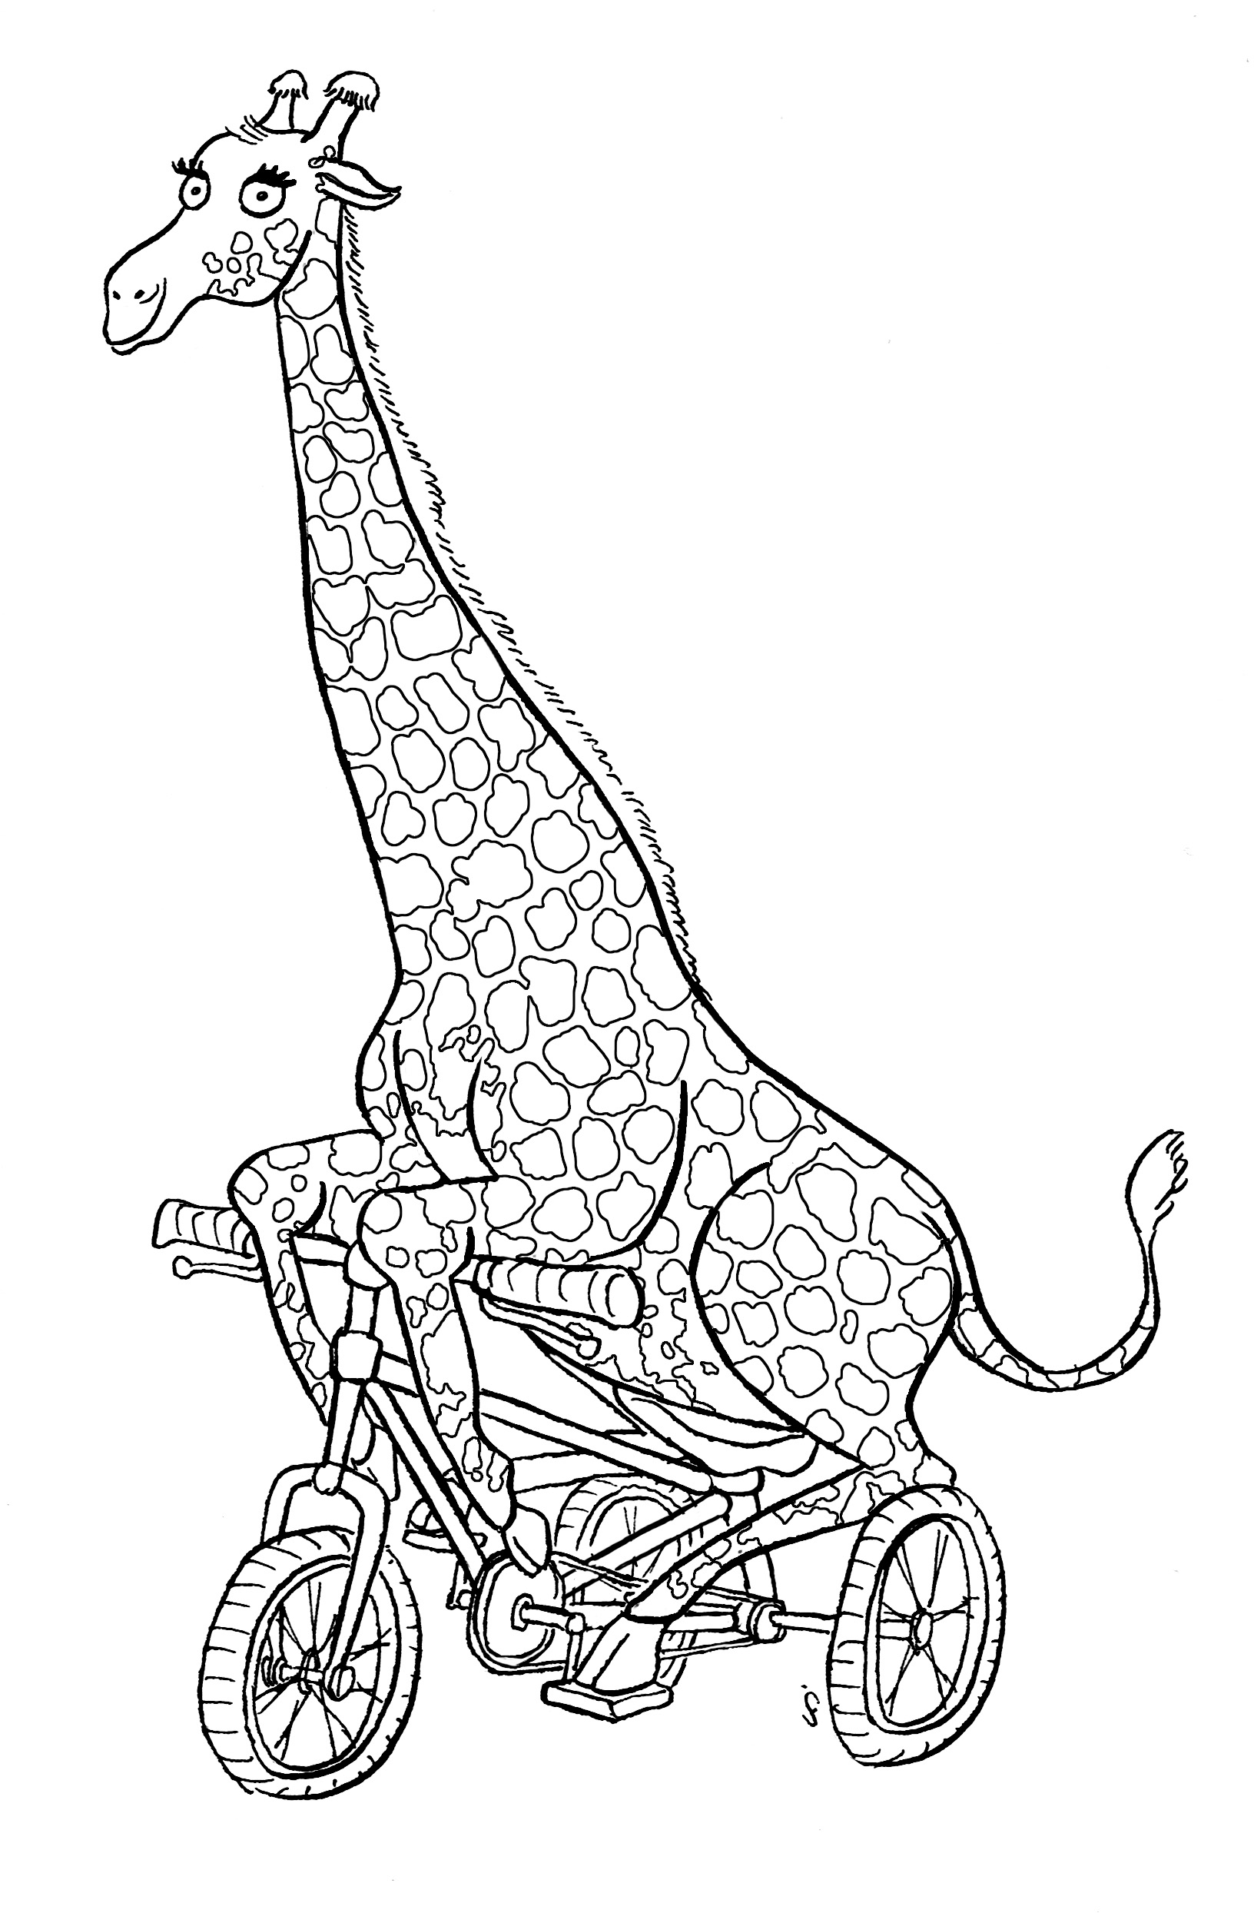
Description; Small Dragon fly made of Steel, wire and bubble wrap
Placement; 200R Obley rd Toongi (left side) 45km
Eye Spy; What is the mailbox?

- Going Home by Robert Miller
Description A Black cow with her calf in tow heading
home from the long paddock.
Placement; “Allambie Stud” 197 Obley st Dubbo (left hand side) 45km
Eye Spy question; What are the numbers on the ear tags?

- Pelicycle by Rowena Galway +Latex bedding team
Description: A tricky Australian Pelican showing off
his balancing techniques on a unicycle.
Placement: Dundullimal homestead entrance
(right hand side approaching Dubbo)
Distance ; 64km from Yeoval and 1km to Newell highway
Eye Spy question; What material is the pelican made from?
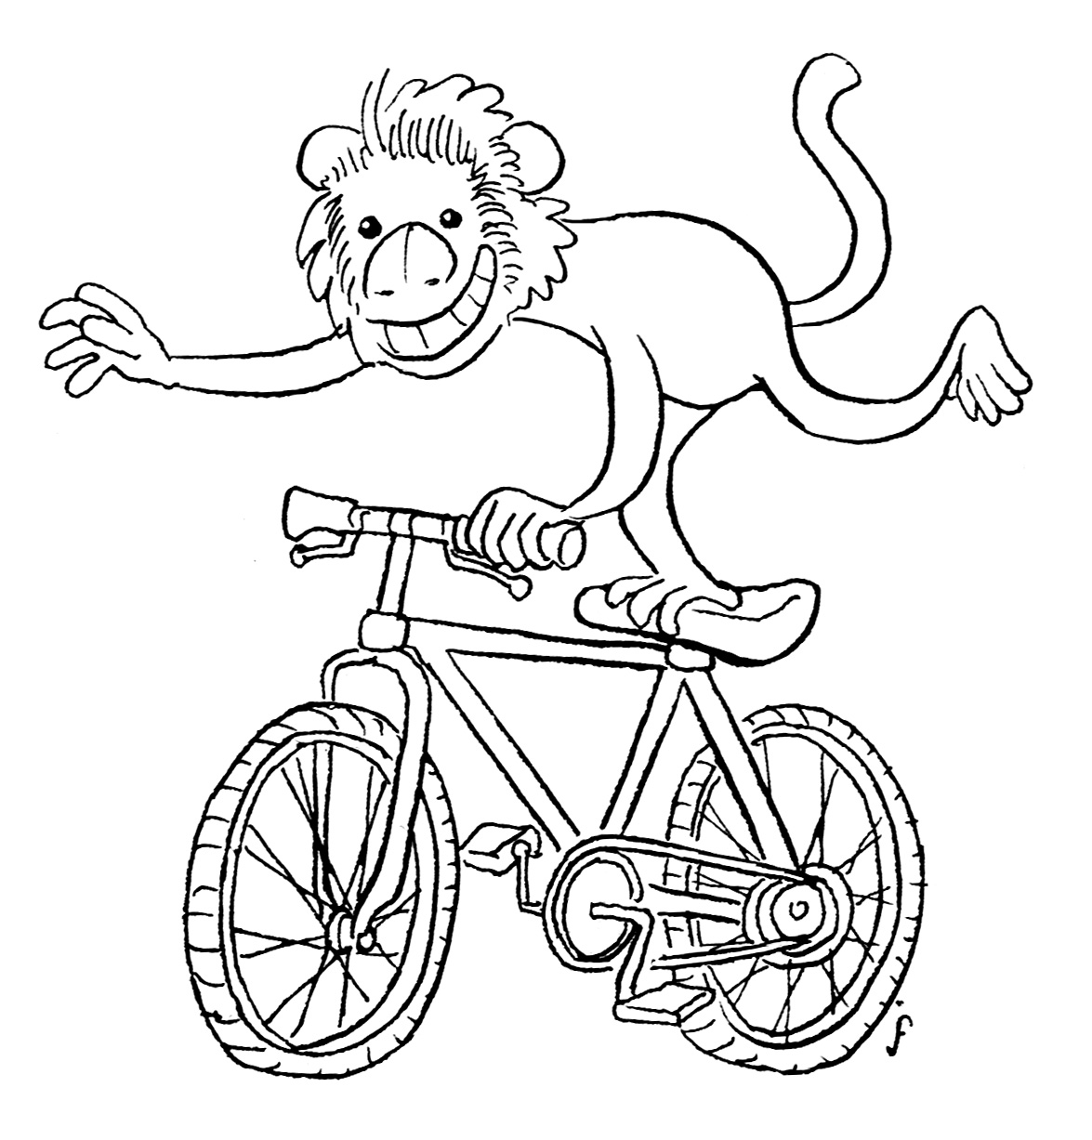

………………………………………………………………….. ………………………………………………………………
Colour-in and name the above “Animals on Bikes”

Which number is your favourite animal on a bike sculpture?.................

We hope you enjoyed spotting the different animals and playing Eye spy on your journey along Obley rd.

There will be new and exciting paddock art sculptures every 2 years….so please come again!

“Animals on Bikes” wrapping paper/tourist map available for $2 from local Tourists centres and cafes.

www.animalsonbikes.com.au would like to THANK www.cabonnecountry.com, www.dubbo.com.au and www.orange.nsw.gov.au for supporting our community project.

